DR. AMBEDKAR COLLEGE, DEEKSHABHOOMI, NAGPUR
DEPARTMENT OF LAW
ACADEMIC SESSION 2022-23
REPORT OF AWARD CEREMONY- 2022

NAME OF THE PROGRAMME: Academic Excellence Award Ceremony- 2022
DATE AND DAY: 28TH September 2022, Wednesday
TIME: 11:30 AM
VENUE: Seminar room, Department of law, Dr.Ambedkar College, Deekshabhoomi
PROGRAMME SUPERVISOR: Dr. H.V. Menon
PROGRAMME CO-COORDINATOR: Mrs. Vaishali A. Sukhdeve

An Award ceremony to felicitate the toppers of the academic year 2021-2022 of LLB 3 years and 5 years course was organised by Department of Law, Dr. Ambedkar College Nagpur. The ceremony was graced by Chief guest, Adv. Sudhir Meshram, Dr. Sudhir S. Fulzele , Secretary, Param Pujya Dr. Babasaheb Ambedkar Smarak Samiti, Principal Dr. Mrs. B.A Mehre, Head of the department of law Dr. H.V. Menon and all the teaching staff. The ceremony began with the blessings of Lord Gautam Buddha and Dr. Babasaheb Ambedkar through traditional offering of devotion by garlanding of their portraits and lighting the candles by the chief guests and the dignitaries present on the dais. The welcome address was delivered by the Principal of the College, Dr. B.A. Mehere.
The Academic excellence Awards for this ceremony were sponsored and instituted by Adv. Sudhir Meshram in the memory of his father, Late, Adv. Shri. Sakharampant Meshram, former Mayor, Nagpur and first Chairperson of Param Pujya Dr. Babasaheb Ambedkar Smarak Samiti. Along with this, to commemorate the birth anniversary of Late, Adv. Shri. Sakharampant Meshram, a lecture series was also inaugurated on this occasion. The first lecture of the series was delivered by Adv. Meshram Sudhir Meshram who explained the importance of Law education and its significance for the society, where he advised the students to be well versed with Legal citations as well as application and interpretation of relevant legal provisions. Adv. Sudhir Meshram, also stated about the accomplishments and struggles of his father in whose remembrance the award is instituted. Presidential Address by Dr. Sudhir S. Fulzele, Secretary, PP Dr. Babasaheb Ambedkar Smarak Samiti was an inspiration to the law students, where he congratulated the students to be part of the prime institution and also emphasized on the importance of teacher’s role in an institution.
The awardees in the ceremony were Mr. Ved Gulaxe, highest sorcerer of LLB 3 years Course and Ms. Soniya Srinivasan, who secured highest aggregate marks in LLB 5 years course , batch of 2021-22. The vote of thanks was proposed by Prof. Dr. H.V. Menon, Head, Department of Law. The program was conducted by Mrs. Vaishali A. Sukhdeve, Assistant Professor. All the faculties of Department of Law were present and graced the ceremony and congratulated the awardees. The students of LLB 3 years and 5 years were also present to witness the ceremony.
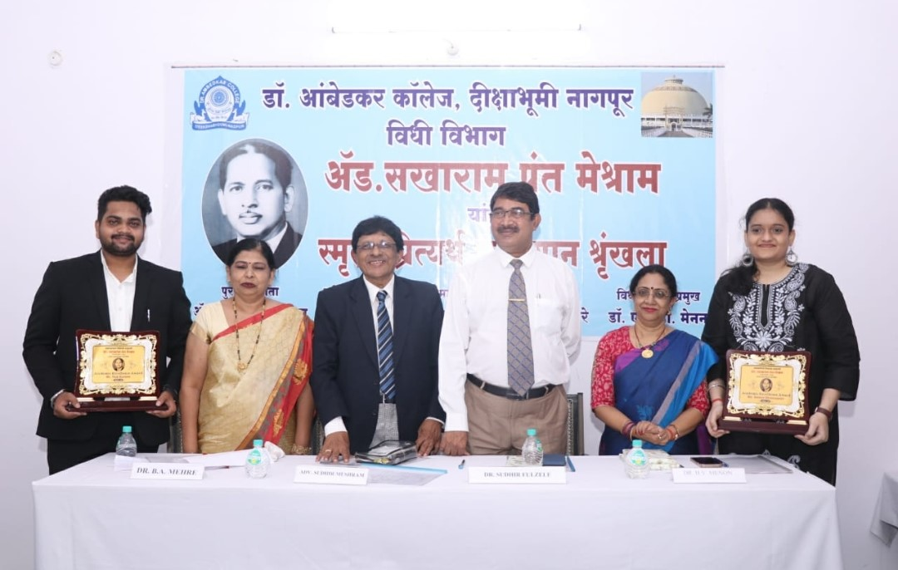
Adv. Sudhir Meshram, Dr. Sudhir Fulzele, Dr. B.A. Mehere, Prof. Dr. H.V. Menon along with the awardees Mr. Ved Gulaxe and Ms. Sonia Srinivasan.
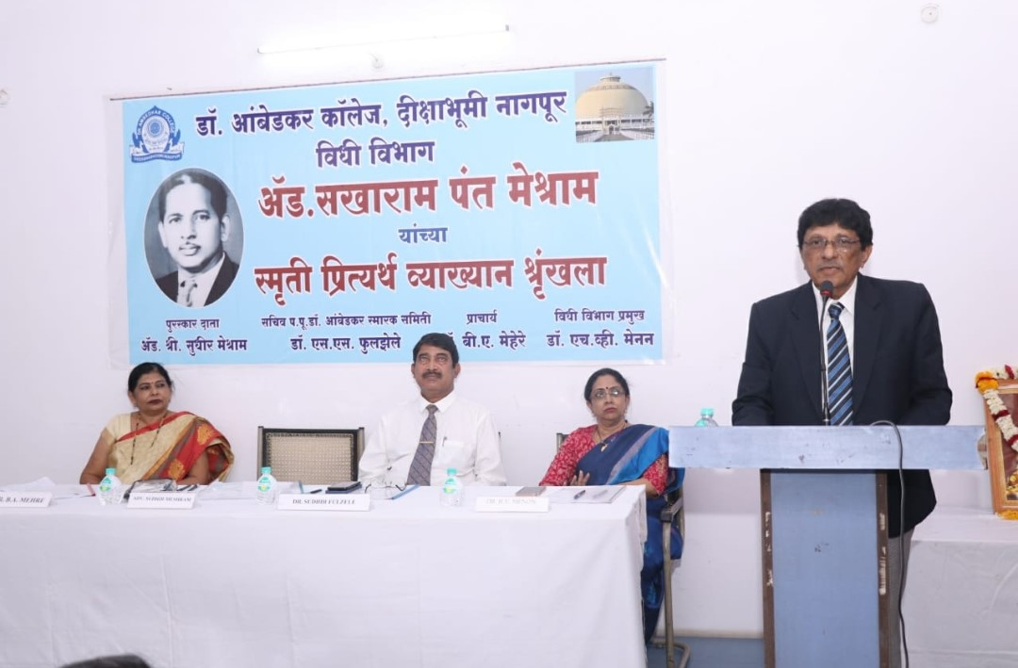
Adv. Sudhir Meshram, Chief guest and first speaker of the lecture series, commemorating the birth anniversary of Late, Adv. Shri. Sakharampant Meshram

